How to flash JJ4X4如何刷JJ4X4
1\Connect your JJ4X4 to PC将JJ4X4连接电脑
2\Open BootMapperClient.exe打开BootMapperClient.exe
3\Click Download点击Download
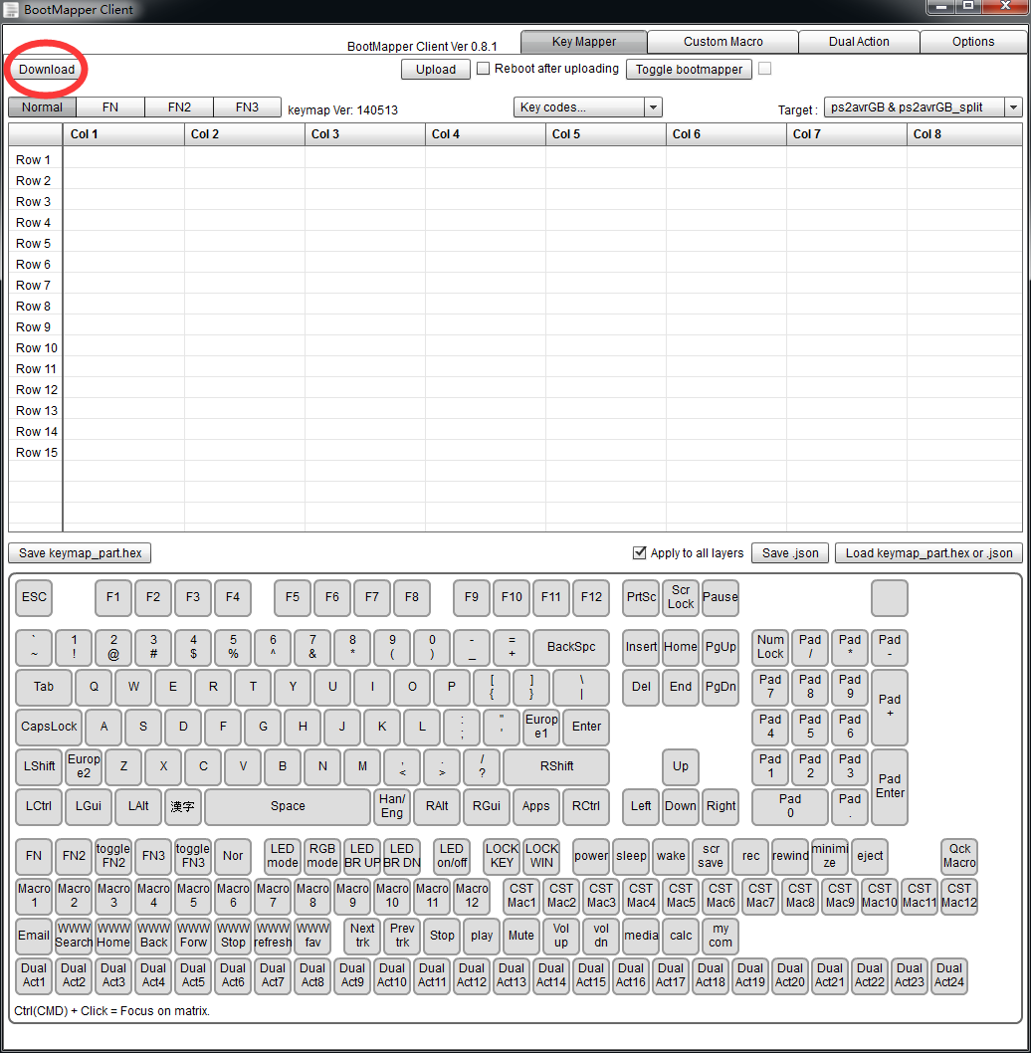
4\If you want to Change 879+ to wasd, just click 879+, bottom colour turn to red, then click w\a\s\d, finally click Upload to put new layout into JJ4X4如果你想把789+换成wasd，只需要点击8，在下面的选择W，以此类推换79+替换即可。换好之后点击upload
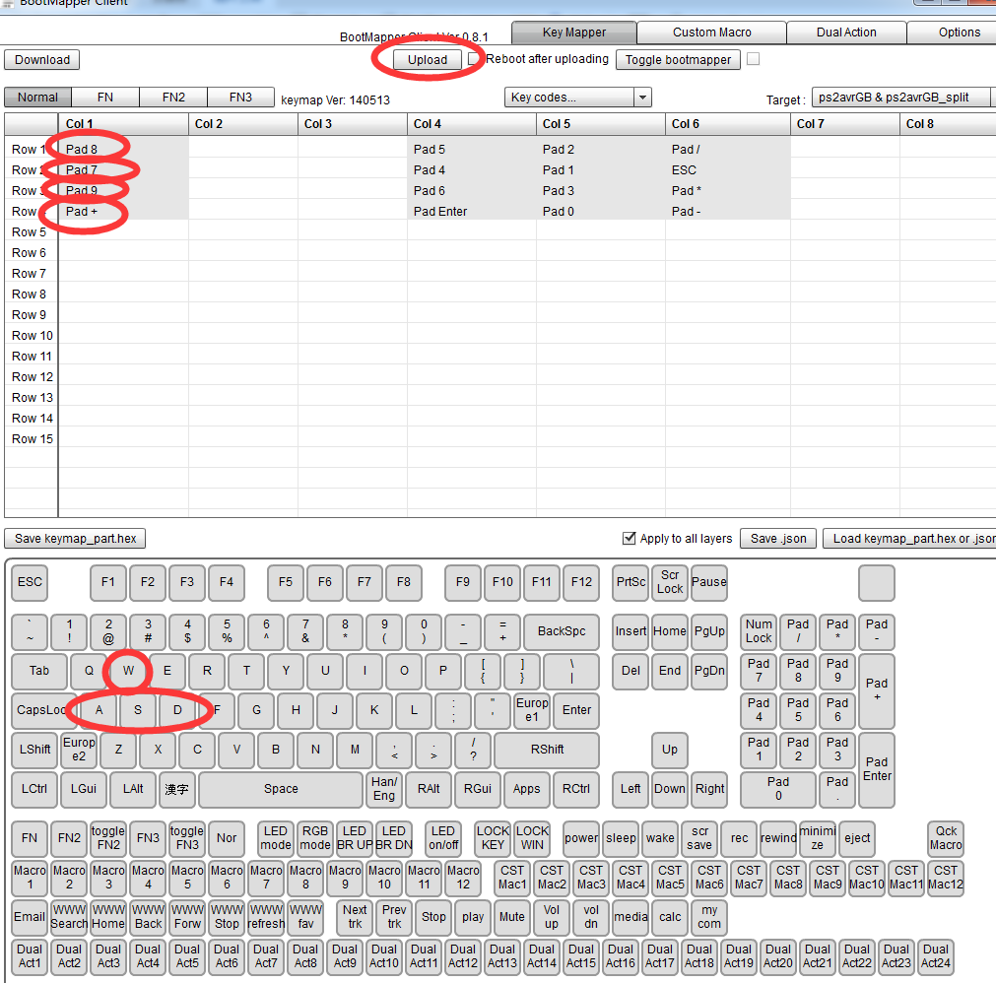
5\Re plug your JJ4X4 PCB to finish all.重新插拔JJ4X4完成刷机
6\If you want to change switches LED mode or RGB underglow mode, click Option, then Connect如果你想改变灯光模式，点击Option,然后点connect
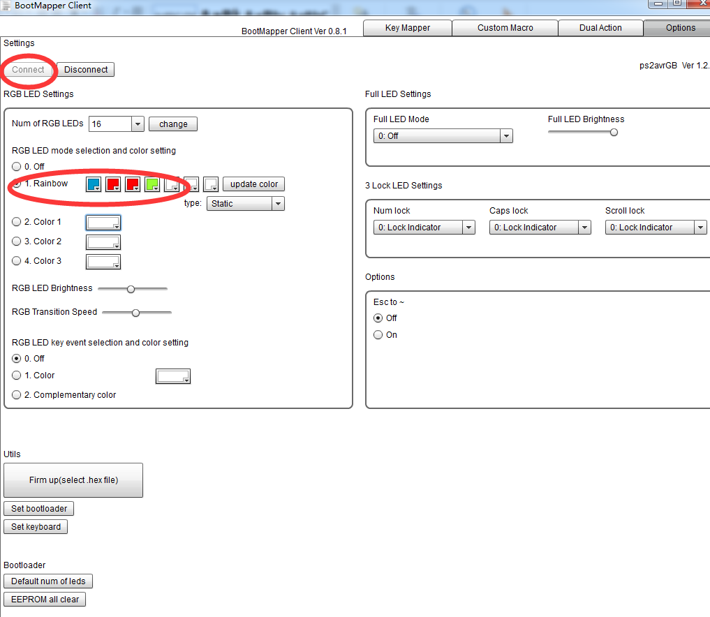
7\Changing full LED settings options, after finish all, click Disconnect to make sure LED settings go into effect 改变full led setting选项，设置好以后，点disconnect断开连接确保效果生效。
